User documentation

# Step-by-step manual

* 1. To launch the program click on an icon:
  2. A similar window will appear:

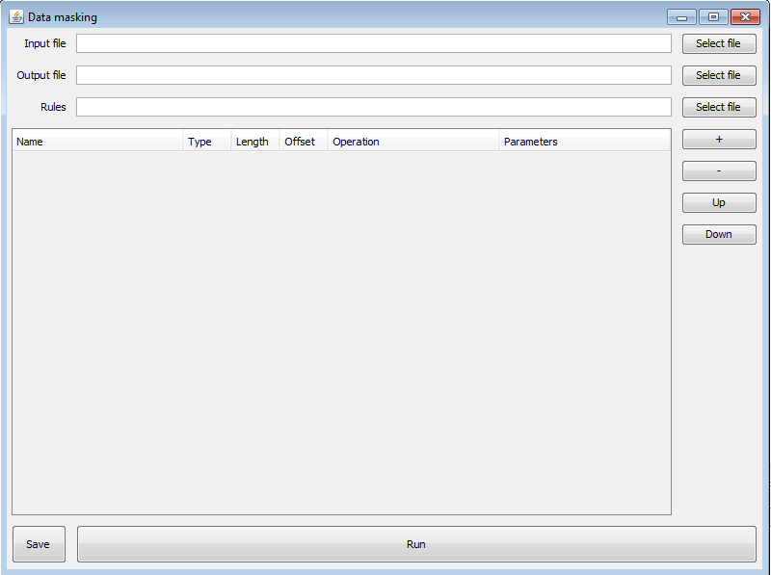

* 1. Input

In the text area labeled input insert the directory to the text file containing data you wish to mask.



* 1. Output

Insert the directory to the text file you wish to use as your final (masked) database. You can also just type in a directory to a file which does not exist yet and the program will create it. In this case do not forget to add the .txt ending to the text file name.



* 1. Rules

Choose if you wish to upload a masker rules file or setting the rules manually in the table below.

#### In the text area labeled rules insert a text file containing masking rules for earlier provided database (see 1.1. input). For more information on creating a file containing masking rules see below.



##### Set the rules for each column manually

…

### Run the program

Click on the run button. See the output file for masked data.

# Masking Rules

The program will rewrite the given data according to given rules. User may create these rules either manually (in upcoming GUI version) or they can input a file with rules specific to the data provided earlier.

## Manual listing

The configuration file (Masking rules file) is a text file containing a name, data type, length, offset, command and parameter for each column of the data provided. User is required to know the number of columns in the database.

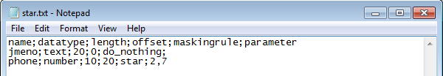

*Masking rule for each column is listed in a line corresponding to its position in database (rule on line 2 in star.txt will mask column no.2 in given database).*

## List of commands:

do_nothing

star; offset min, offset max

random_number; min,max

replace_from_seeds_file; seeds file directory

random_phone_number

replace_with_random_digits; offset min, offset max

random_rc

IBAN

### **do_nothing**

Command do_nothing will leave the column without any changes.

### **star**

Command star will replace the data with stars.

*Data example with 3 columns and 1 row*



*Example of rules file*



*Output file after running the program*

**

The star command can be used with an offset parameter. Then it will replace just the given part of the column.



*The line above will return:*



ATTENTION: Notice that there is no semicolon after the parameter!

### **random_number; min, max**

Command random_number will replace the data with a randomly generated number. User can choose the range of the number. If a parameter is not given, the command will generate a random number that will fill out the entire offset of a column.

### **replace_from_seeds_file; seeds file directory**

Command replace_seeds will replace the data with a data from a given seed. Seed directory is required parameter.

### **random_phone_number**

Command random_phone_number will replace data with a random number in a phone number format. The first three digits will be generated from a seed of commonly used phone number prefixes.

### **replace_with_random_digits; min, max**

The data in a given offset will be replaced with random digits.

The parameter is not required. In that case this command will replace the whole offset of a given column.

### **random_rc**

Command random_rc will replace a data with a number simulating the national identification number format.

### **IBAN**

Command IBAN will generate data simulating the IBAN format.

ATTENTION: If user adds command incorrectly or leaves an empty space where command is expected, the program will crash.